**1.Create a Spring Web Project using Maven**

* Group ID: com.cognizant
* Artifact ID: spring-learn
* Spring Boot Version: 3.5.3
* Build Tool: Maven
* Java Version: 17

**Command to be run in terminal:**

mvn -Dhttp.proxyHost=proxy.cognizant.com -Dhttp.proxyPort=6050 -Dhttps.proxyHost=proxy.cognizant.com -Dhttps.proxyPort=6050 -Dhttp.proxyUser=123456 clean package

**SpringLearnApplication.java:**

package com.cognizant.spring_learn;  
  
import org.springframework.boot.SpringApplication;  
import org.springframework.boot.autoconfigure.SpringBootApplication;  
  
@SpringBootApplication  
public class SpringLearnApplication {  
  
 public static void main(String[] args) {  
 System.*out*.println("Spring Boot Application Started...");  
 SpringApplication.*run*(SpringLearnApplication.class, args);  
 }  
}

**Pom.xml:**

<?xml version="1.0" encoding="UTF-8"?>  
<project xmlns="http://maven.apache.org/POM/4.0.0" xmlns:xsi="http://www.w3.org/2001/XMLSchema-instance"  
 xsi:schemaLocation="http://maven.apache.org/POM/4.0.0 https://maven.apache.org/xsd/maven-4.0.0.xsd">  
 <modelVersion>4.0.0</modelVersion>  
 <parent>  
 <groupId>org.springframework.boot</groupId>  
 <artifactId>spring-boot-starter-parent</artifactId>  
 <version>3.5.3</version>  
 <relativePath/>   
 </parent>  
 <groupId>com.cognizant</groupId>  
 <artifactId>spring-learn</artifactId>  
 <version>0.0.1-SNAPSHOT</version>  
 <name>spring-learn</name>  
 <description>Demo project for Spring Boot</description>  
 <url/>  
 <licenses>  
 <license/>  
 </licenses>  
 <developers>  
 <developer/>  
 </developers>  
 <scm>  
 <connection/>  
 <developerConnection/>  
 <tag/>  
 <url/>  
 </scm>  
 <properties>  
 <java.version>17</java.version>  
 </properties>  
 <dependencies>  
 <dependency>  
 <groupId>org.springframework.boot</groupId>  
 <artifactId>spring-boot-starter-web</artifactId>  
 </dependency>  
 <dependency>  
 <groupId>org.springframework.boot</groupId>  
 <artifactId>spring-boot-devtools</artifactId>  
 <scope>runtime</scope>  
 <optional>true</optional>  
 </dependency>  
 <dependency>  
 <groupId>org.springframework.boot</groupId>  
 <artifactId>spring-boot-starter-test</artifactId>  
 <scope>test</scope>  
 </dependency>  
 </dependencies>  
  
 <build>  
 <plugins>  
 <plugin>  
 <groupId>org.springframework.boot</groupId>  
 <artifactId>spring-boot-maven-plugin</artifactId>  
 </plugin>  
 </plugins>  
 </build>  
  
</project>

**OUTPUT:**

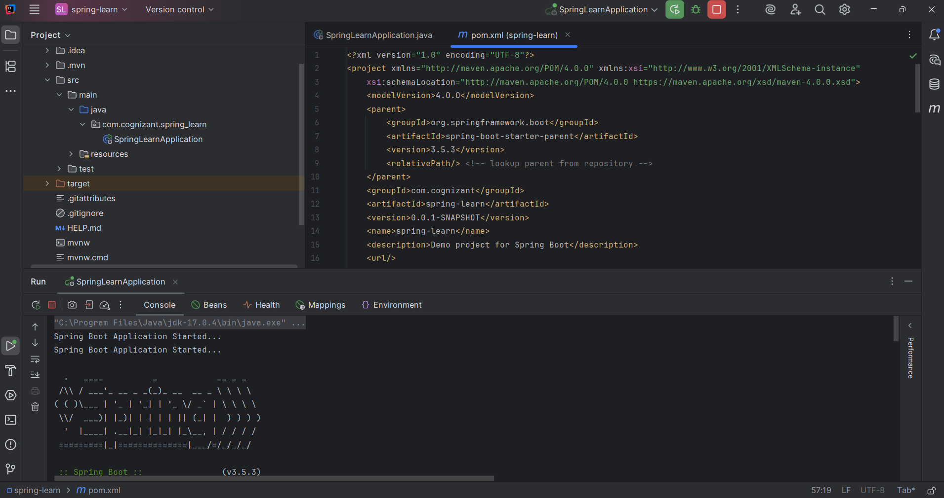

**2.Spring Core – Load Country from Spring Configuration XML**

**Pom.xml:**

<?xml version="1.0" encoding="UTF-8"?>  
<project xmlns="http://maven.apache.org/POM/4.0.0" xmlns:xsi="http://www.w3.org/2001/XMLSchema-instance"  
 xsi:schemaLocation="http://maven.apache.org/POM/4.0.0 https://maven.apache.org/xsd/maven-4.0.0.xsd">  
 <modelVersion>4.0.0</modelVersion>  
 <parent>  
 <groupId>org.springframework.boot</groupId>  
 <artifactId>spring-boot-starter-parent</artifactId>  
 <version>3.5.3</version>  
 <relativePath/>  
 </parent>  
 <groupId>com.cognizant</groupId>  
 <artifactId>spring-learn</artifactId>  
 <version>0.0.1-SNAPSHOT</version>  
 <name>spring-learn</name>  
 <description>Demo project for Spring Boot</description>  
 <url/>  
 <licenses>  
 <license/>  
 </licenses>  
 <developers>  
 <developer/>  
 </developers>  
 <scm>  
 <connection/>  
 <developerConnection/>  
 <tag/>  
 <url/>  
 </scm>  
 <properties>  
 <java.version>17</java.version>  
 </properties>  
 <dependencies>  
 <dependency>  
 <groupId>org.springframework.boot</groupId>  
 <artifactId>spring-boot-starter-web</artifactId>  
 </dependency>  
 <dependency>  
 <groupId>org.springframework.boot</groupId>  
 <artifactId>spring-boot-devtools</artifactId>  
 <scope>runtime</scope>  
 <optional>true</optional>  
 </dependency>  
 <dependency>  
 <groupId>org.springframework.boot</groupId>  
 <artifactId>spring-boot-starter-test</artifactId>  
 <scope>test</scope>  
 </dependency>  
 <dependency>  
 <groupId>org.springframework.boot</groupId>  
 <artifactId>spring-boot-starter-logging</artifactId>  
 </dependency>  
  
 </dependencies>  
  
 <build>  
 <plugins>  
 <plugin>  
 <groupId>org.springframework.boot</groupId>  
 <artifactId>spring-boot-maven-plugin</artifactId>  
 </plugin>  
 </plugins>  
 </build>  
  
</project>

**country.xml:**

<?xml version="1.0" encoding="UTF-8"?>  
<beans xmlns="http://www.springframework.org/schema/beans"  
 xmlns:xsi="http://www.w3.org/2001/XMLSchema-instance"  
 xsi:schemaLocation="  
 http://www.springframework.org/schema/beans  
 http://www.springframework.org/schema/beans/spring-beans.xsd">  
  
 <bean id="country" class="com.cognizant.spring_learn.Country">  
 <property name="code" value="IN" />  
 <property name="name" value="India" />  
 </bean>  
  
</beans>

**Country.java:**

package com.cognizant.spring_learn;  
  
import org.slf4j.Logger;  
import org.slf4j.LoggerFactory;  
  
public class Country {  
 private static final Logger *LOGGER* = LoggerFactory.*getLogger*(Country.class);  
  
 private String code;  
 private String name;  
  
 public Country() {  
 *LOGGER*.debug("Inside Country Constructor");  
 }  
  
 public String getCode() {  
 return code;  
 }  
  
 public void setCode(String code) {  
 *LOGGER*.debug("Inside setCode()");  
 this.code = code;  
 }  
  
 public String getName() {  
 return name;  
 }  
  
 public void setName(String name) {  
 *LOGGER*.debug("Inside setName()");  
 this.name = name;  
 }  
  
 @Override  
 public String toString() {  
 return "Country [code=" + code + ", name=" + name + "]";  
 }  
}

**SpringLearnApplication.java:**

package com.cognizant.spring_learn;  
  
import org.slf4j.Logger;  
import org.slf4j.LoggerFactory;  
import org.springframework.context.ApplicationContext;  
import org.springframework.context.support.ClassPathXmlApplicationContext;  
  
public class SpringLearnApplication {  
  
 private static final Logger *LOGGER* = LoggerFactory.*getLogger*(SpringLearnApplication.class);  
  
 public static void main(String[] args) {  
 *LOGGER*.info("START");  
  
 *displayCountry*();  
  
 *LOGGER*.info("END");  
 }  
  
 public static void displayCountry() {  
 ApplicationContext context = new ClassPathXmlApplicationContext("country.xml");  
  
 Country country = context.getBean("country", Country.class);  
  
 *LOGGER*.debug("Country : {}", country.toString());  
 }  
}

**OUTPUT:**

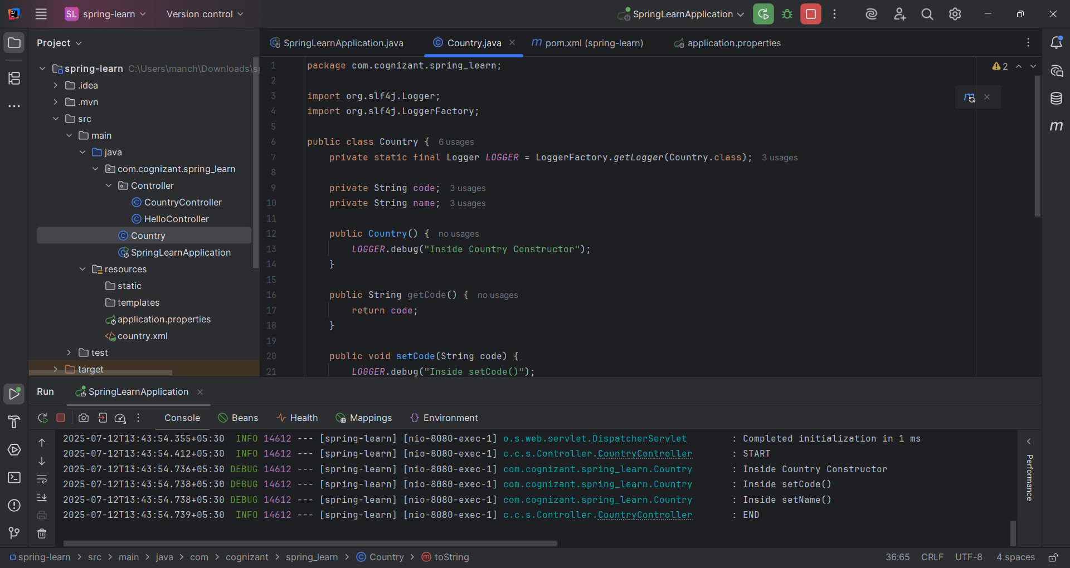

**3.Hello World RESTful Web Service**

**Pom.xml:**

<?xml version="1.0" encoding="UTF-8"?>  
<project xmlns="http://maven.apache.org/POM/4.0.0" xmlns:xsi="http://www.w3.org/2001/XMLSchema-instance"  
 xsi:schemaLocation="http://maven.apache.org/POM/4.0.0 https://maven.apache.org/xsd/maven-4.0.0.xsd">  
 <modelVersion>4.0.0</modelVersion>  
 <parent>  
 <groupId>org.springframework.boot</groupId>  
 <artifactId>spring-boot-starter-parent</artifactId>  
 <version>3.5.3</version>  
 <relativePath/>  
 </parent>  
 <groupId>com.cognizant</groupId>  
 <artifactId>spring-learn</artifactId>  
 <version>0.0.1-SNAPSHOT</version>  
 <name>spring-learn</name>  
 <description>Demo project for Spring Boot</description>  
 <url/>  
 <licenses>  
 <license/>  
 </licenses>  
 <developers>  
 <developer/>  
 </developers>  
 <scm>  
 <connection/>  
 <developerConnection/>  
 <tag/>  
 <url/>  
 </scm>  
 <properties>  
 <java.version>17</java.version>  
 </properties>  
 <dependencies>  
 <dependency>  
 <groupId>org.springframework.boot</groupId>  
 <artifactId>spring-boot-starter-web</artifactId>  
 </dependency>  
 <dependency>  
 <groupId>org.springframework.boot</groupId>  
 <artifactId>spring-boot-devtools</artifactId>  
 <scope>runtime</scope>  
 <optional>true</optional>  
 </dependency>  
 <dependency>  
 <groupId>org.springframework.boot</groupId>  
 <artifactId>spring-boot-starter-test</artifactId>  
 <scope>test</scope>  
 </dependency>  
 <dependency>  
 <groupId>org.springframework.boot</groupId>  
 <artifactId>spring-boot-starter-logging</artifactId>  
 </dependency>  
  
 </dependencies>  
  
 <build>  
 <plugins>  
 <plugin>  
 <groupId>org.springframework.boot</groupId>  
 <artifactId>spring-boot-maven-plugin</artifactId>  
 </plugin>  
 </plugins>  
 </build>  
  
</project>

**HelloController.java:**

package com.cognizant.spring_learn.Controller;  
  
import org.slf4j.Logger;  
import org.slf4j.LoggerFactory;  
import org.springframework.web.bind.annotation.GetMapping;  
import org.springframework.web.bind.annotation.RestController;  
  
@RestController  
public class HelloController {  
  
 private static final Logger *LOGGER* = LoggerFactory.*getLogger*(HelloController.class);  
  
 @GetMapping("/hello")  
 public String sayHello() {  
 *LOGGER*.info("START");  
 String message = "Hello World!!";  
 *LOGGER*.info("END");  
 return message;  
 }  
}

**SpringLearnApplication.java:**

package com.cognizant.spring_learn;  
import org.springframework.boot.SpringApplication;  
import org.springframework.boot.autoconfigure.SpringBootApplication;  
  
@SpringBootApplication  
public class SpringLearnApplication {  
 public static void main(String[] args) {  
 SpringApplication.*run*(SpringLearnApplication.class, args);  
 }  
}

**OUTPUT:**

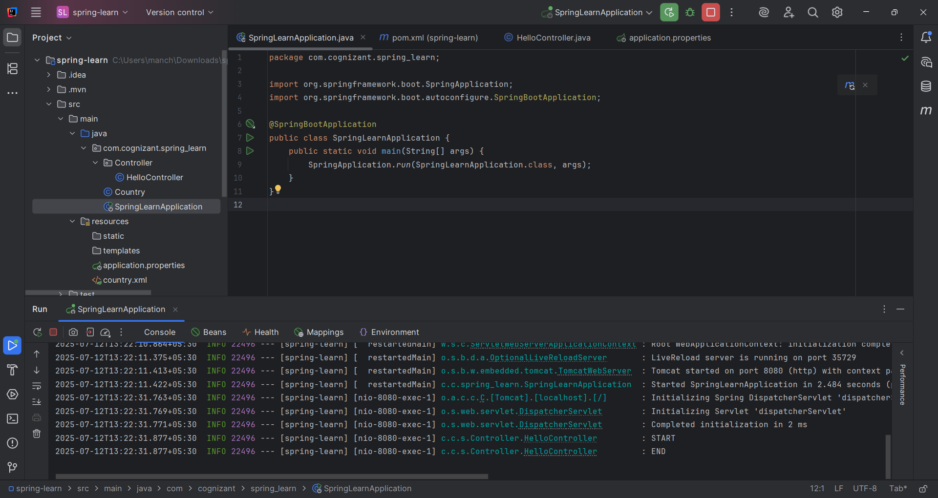

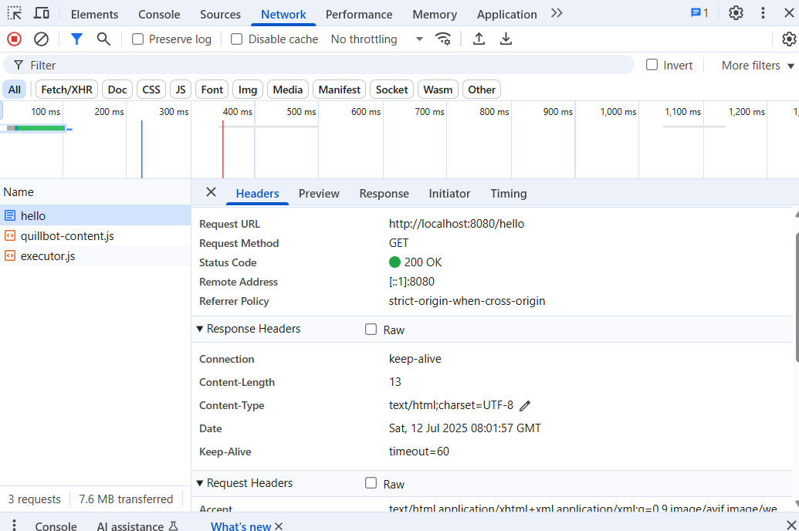

**4.REST - Country Web Service**

**CountryController.java:**

package com.cognizant.spring_learn.Controller;  
  
import com.cognizant.spring_learn.Country;  
import org.slf4j.Logger;  
import org.slf4j.LoggerFactory;  
import org.springframework.context.ApplicationContext;  
import org.springframework.context.support.ClassPathXmlApplicationContext;  
import org.springframework.web.bind.annotation.RequestMapping;  
import org.springframework.web.bind.annotation.RestController;  
  
@RestController  
public class CountryController {  
  
 private static final Logger *LOGGER* = LoggerFactory.*getLogger*(CountryController.class);  
  
 @RequestMapping("/country")  
 public Country getCountryIndia() {  
 *LOGGER*.info("START");  
 ApplicationContext context = new ClassPathXmlApplicationContext("country.xml");  
 Country country = (Country) context.getBean("country");  
 *LOGGER*.info("END");  
 return country;  
 }  
}

**country.xml:**

<?xml version="1.0" encoding="UTF-8"?>  
<beans xmlns="http://www.springframework.org/schema/beans"  
 xmlns:xsi="http://www.w3.org/2001/XMLSchema-instance"  
 xsi:schemaLocation="  
 http://www.springframework.org/schema/beans  
 http://www.springframework.org/schema/beans/spring-beans.xsd">  
  
 <bean id="country" class="com.cognizant.spring_learn.Country">  
 <property name="code" value="IN" />  
 <property name="name" value="India" />  
 </bean>  
  
</beans>

**Country.java:**

package com.cognizant.spring_learn;  
  
import org.slf4j.Logger;  
import org.slf4j.LoggerFactory;  
  
public class Country {  
 private static final Logger *LOGGER* = LoggerFactory.*getLogger*(Country.class);  
  
 private String code;  
 private String name;  
  
 public Country() {  
 *LOGGER*.debug("Inside Country Constructor");  
 }  
  
 public String getCode() {  
 return code;  
 }  
  
 public void setCode(String code) {  
 *LOGGER*.debug("Inside setCode()");  
 this.code = code;  
 }  
  
 public String getName() {  
 return name;  
 }  
  
 public void setName(String name) {  
 *LOGGER*.debug("Inside setName()");  
 this.name = name;  
 }  
  
 @Override  
 public String toString() {  
 return "Country [code=" + code + ", name=" + name + "]";  
 }  
}

**SpringLearnApplication.java:**

package com.cognizant.spring_learn;  
  
import org.slf4j.Logger;  
import org.slf4j.LoggerFactory;  
import org.springframework.context.ApplicationContext;  
import org.springframework.context.support.ClassPathXmlApplicationContext;  
  
public class SpringLearnApplication {  
  
 private static final Logger *LOGGER* = LoggerFactory.*getLogger*(SpringLearnApplication.class);  
  
 public static void main(String[] args) {  
 *LOGGER*.info("START");  
  
 *displayCountry*();  
  
 *LOGGER*.info("END");  
 }  
  
 public static void displayCountry() {  
 ApplicationContext context = new ClassPathXmlApplicationContext("country.xml");  
 Country country = context.getBean("country", Country.class);  
 *LOGGER*.debug("Country : {}", country.toString());  
 }  
}

**OUTPUT:**

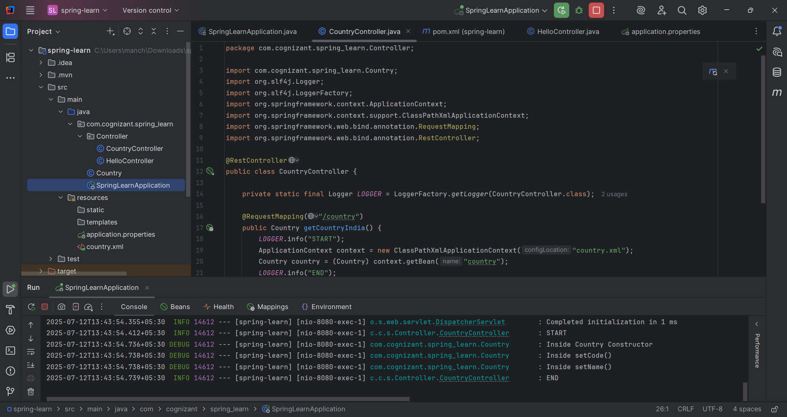

**5.REST - Get country based on country code**

**country.xml:**

<?xml version="1.0" encoding="UTF-8"?>  
<beans xmlns="http://www.springframework.org/schema/beans"  
 xmlns:xsi="http://www.w3.org/2001/XMLSchema-instance"  
 xsi:schemaLocation="http://www.springframework.org/schema/beans  
 http://www.springframework.org/schema/beans/spring-beans.xsd">  
  
 <bean id="countryList" class="java.util.ArrayList">  
 <constructor-arg>  
 <list>  
 <bean class="com.cognizant.spring_learn.Country">  
 <property name="code" value="IN" />  
 <property name="name" value="India" />  
 </bean>  
 <bean class="com.cognizant.spring_learn.Country">  
 <property name="code" value="US" />  
 <property name="name" value="United States" />  
 </bean>  
 <bean class="com.cognizant.spring_learn.Country">  
 <property name="code" value="CN" />  
 <property name="name" value="China" />  
 </bean>  
 </list>  
 </constructor-arg>  
 </bean>  
  
</beans>

**Country.java:**

package com.cognizant.spring_learn;  
  
import org.slf4j.Logger;  
import org.slf4j.LoggerFactory;  
  
public class Country {  
 private static final Logger *LOGGER* = LoggerFactory.*getLogger*(Country.class);  
  
 private String code;  
 private String name;  
  
 public Country() {  
 *LOGGER*.debug("Inside Country Constructor");  
 }  
  
 public String getCode() {  
 return code;  
 }  
  
 public void setCode(String code) {  
 *LOGGER*.debug("Inside setCode()");  
 this.code = code;  
 }  
  
 public String getName() {  
 return name;  
 }  
  
 public void setName(String name) {  
 *LOGGER*.debug("Inside setName()");  
 this.name = name;  
 }  
  
 @Override  
 public String toString() {  
 return "Country [code=" + code + ", name=" + name + "]";  
 }  
}

**CountryService.java:**

package com.cognizant.spring_learn.service;

import com.cognizant.spring_learn.Country;

import org.springframework.beans.factory.annotation.Autowired;

import org.springframework.context.ApplicationContext;

import org.springframework.stereotype.Service;

import java.util.List;

@Service

public class CountryService {

@Autowired

private ApplicationContext context;

public Country getCountry(String code) {

@SuppressWarnings("unchecked")

List<Country> countries = (List<Country>) context.getBean("countryList");

return countries.stream()

.filter(c -> c.getCode().equalsIgnoreCase(code))

.findFirst()

.orElseThrow(() -> new CountryNotFoundException("Country not found for code: " + code));

}

}

**CountryNotFoundException.java**

package com.cognizant.spring_learn.exception;  
  
public class CountryNotFoundException extends RuntimeException {  
 public CountryNotFoundException(String message) {  
 super(message);  
 }  
}

**CountryController.java:**

package com.cognizant.spring_learn.controller;

import com.cognizant.spring_learn.Country;

import com.cognizant.spring_learn.service.CountryService;

import org.slf4j.Logger;

import org.slf4j.LoggerFactory;

import org.springframework.beans.factory.annotation.Autowired;

import org.springframework.web.bind.annotation.*;

@RestController

public class CountryController {

private static final Logger LOGGER = LoggerFactory.getLogger(CountryController.class);

@Autowired

private CountryService countryService;

@GetMapping("/countries/{code}")

public Country getCountry(@PathVariable String code) {

LOGGER.info("START");

Country country = countryService.getCountry(code);

LOGGER.debug("Country: {}", country);

LOGGER.info("END");

return country;

}

}

**SpringLearnApplication.java:**

package com.cognizant.spring_learn;  
  
import org.springframework.boot.SpringApplication;  
import org.springframework.boot.autoconfigure.SpringBootApplication;  
import org.springframework.context.annotation.ImportResource;  
  
@SpringBootApplication  
@ImportResource("classpath:country.xml")  
public class SpringLearnApplication {  
 public static void main(String[] args) {  
 SpringApplication.*run*(SpringLearnApplication.class, args);  
 }  
}

**OUTPUT:**

**6.Create authentication service that returns JWT**

**JwtUtil.java:**

package com.cognizant.spring_learn.util;  
  
import io.jsonwebtoken.Jwts;  
import io.jsonwebtoken.SignatureAlgorithm;  
import org.springframework.stereotype.Component;  
  
import java.util.Date;  
  
@Component  
public class JwtUtil {  
  
 private final String SECRET_KEY = "secret123";  
  
 public String generateToken(String username) {  
 return Jwts.*builder*()  
 .setSubject(username)  
 .setIssuedAt(new Date(System.*currentTimeMillis*()))  
 .setExpiration(new Date(System.*currentTimeMillis*() + 1000 * 60 * 60 * 10)) // 10 hours  
 .signWith(SignatureAlgorithm.*HS256*, SECRET_KEY)  
 .compact();  
 }  
}

**AuthController.java:**

package com.cognizant.spring_learn.Controller;  
  
import com.cognizant.spring_learn.util.JwtUtil;  
import org.springframework.beans.factory.annotation.Autowired;  
import org.springframework.http.ResponseEntity;  
import org.springframework.security.crypto.bcrypt.BCryptPasswordEncoder;  
import org.springframework.web.bind.annotation.*;  
  
import java.util.Base64;  
  
@RestController  
public class AuthController {  
  
 @Autowired  
 private JwtUtil jwtUtil;  
  
 // Simulated user credentials (username: user, password: pwd)  
 private final String hardcodedUsername = "user";  
 private final String hardcodedPassword = "pwd";  
  
 @GetMapping("/authenticate")  
 public ResponseEntity<?> authenticate(@RequestHeader("Authorization") String authHeader) {  
 // Decode Base64 username:password from header  
 String base64Credentials = authHeader.substring("Basic ".length()).trim();  
 byte[] credDecoded = Base64.*getDecoder*().decode(base64Credentials);  
 String credentials = new String(credDecoded);  
 String[] values = credentials.split(":", 2);  
  
 String username = values[0];  
 String password = values[1];  
  
 // Check credentials  
 if (hardcodedUsername.equals(username) && hardcodedPassword.equals(password)) {  
 String token = jwtUtil.generateToken(username);  
 return ResponseEntity.*ok*("{\"token\":\"" + token + "\"}");  
 } else {  
 return ResponseEntity.*status*(401).body("Invalid username or password");  
 }  
 }  
}

**SecurityConfig.java:**

package com.cognizant.spring_learn.config;  
  
import org.springframework.context.annotation.Bean;  
import org.springframework.context.annotation.Configuration;  
import org.springframework.security.authentication.AuthenticationManager;  
import org.springframework.security.config.annotation.authentication.builders.AuthenticationManagerBuilder;  
import org.springframework.security.config.annotation.web.builders.HttpSecurity;  
import org.springframework.security.crypto.password.NoOpPasswordEncoder;  
import org.springframework.security.crypto.password.PasswordEncoder;  
import org.springframework.security.web.SecurityFilterChain;  
  
@Configuration  
public class SecurityConfig {  
  
 @Bean  
 public SecurityFilterChain filterChain(org.springframework.security.config.annotation.web.builders.HttpSecurity http) throws Exception {  
 http  
 .csrf(csrf -> csrf.disable())  
 .authorizeHttpRequests(authz -> authz  
 .anyRequest().authenticated()  
 )  
 .httpBasic();  
 return http.build();  
 }  
  
 @Bean  
 public AuthenticationManager authManager(HttpSecurity http) throws Exception {  
 return http.getSharedObject(AuthenticationManagerBuilder.class)  
 .inMemoryAuthentication()  
 .withUser("user")  
 .password("pwd")  
 .roles("USER")  
 .and()  
 .passwordEncoder(passwordEncoder())  
 .and()  
 .build();  
 }  
  
 @Bean  
 public PasswordEncoder passwordEncoder() {  
 // This is insecure but okay for testing  
 return NoOpPasswordEncoder.*getInstance*();  
 }  
}

**pom.xml:**

<?xml version="1.0" encoding="UTF-8"?>  
<project xmlns="http://maven.apache.org/POM/4.0.0" xmlns:xsi="http://www.w3.org/2001/XMLSchema-instance"  
 xsi:schemaLocation="http://maven.apache.org/POM/4.0.0 https://maven.apache.org/xsd/maven-4.0.0.xsd">  
 <modelVersion>4.0.0</modelVersion>  
 <parent>  
 <groupId>org.springframework.boot</groupId>  
 <artifactId>spring-boot-starter-parent</artifactId>  
 <version>3.5.3</version>  
 <relativePath/>  
 </parent>  
 <groupId>com.cognizant</groupId>  
 <artifactId>spring-learn</artifactId>  
 <version>0.0.1-SNAPSHOT</version>  
 <name>spring-learn</name>  
 <description>Demo project for Spring Boot</description>  
 <url/>  
 <licenses>  
 <license/>  
 </licenses>  
 <developers>  
 <developer/>  
 </developers>  
 <scm>  
 <connection/>  
 <developerConnection/>  
 <tag/>  
 <url/>  
 </scm>  
 <properties>  
 <java.version>17</java.version>  
 </properties>  
 <dependencies>  
 <dependency>  
 <groupId>org.springframework.boot</groupId>  
 <artifactId>spring-boot-starter-web</artifactId>  
 </dependency>  
 <dependency>  
 <groupId>org.springframework.boot</groupId>  
 <artifactId>spring-boot-devtools</artifactId>  
 <scope>runtime</scope>  
 <optional>true</optional>  
 </dependency>  
 <dependency>  
 <groupId>org.springframework.boot</groupId>  
 <artifactId>spring-boot-starter-test</artifactId>  
 <scope>test</scope>  
 </dependency>  
 <dependency>  
 <groupId>org.springframework.boot</groupId>  
 <artifactId>spring-boot-starter-logging</artifactId>  
 </dependency>  
 <dependency>  
 <groupId>org.springframework.boot</groupId>  
 <artifactId>spring-boot-starter-actuator</artifactId>  
 </dependency>  
  
 <dependency>  
 <groupId>org.springframework.boot</groupId>  
 <artifactId>spring-boot-starter-security</artifactId>  
 </dependency>  
  
 <dependency>  
 <groupId>io.jsonwebtoken</groupId>  
 <artifactId>jjwt</artifactId>  
 <version>0.9.1</version>  
 </dependency>  
 <dependency>  
 <groupId>javax.xml.bind</groupId>  
 <artifactId>jaxb-api</artifactId>  
 <version>2.3.1</version>  
 </dependency>  
 <dependency>  
 <groupId>org.glassfish.jaxb</groupId>  
 <artifactId>jaxb-runtime</artifactId>  
 <version>2.3.1</version>  
 </dependency>  
  
  
 </dependencies>  
  
 <build>  
 <plugins>  
 <plugin>  
 <groupId>org.springframework.boot</groupId>  
 <artifactId>spring-boot-maven-plugin</artifactId>  
 </plugin>  
 </plugins>  
 </build>  
  
</project>

**Command in Windows Powershell:**

$base64AuthInfo = [Convert]::ToBase64String([Text.Encoding]::ASCII.GetBytes("user:pwd"))

Invoke-WebRequest -Uri http://localhost:8080/authenticate -Headers @{Authorization=("Basic {0}" -f $base64AuthInfo)} -Method Get

**OUTPUT:**

